Local Negotiating Committee for Teachers – Agreement No.26
Professional Update and Professional Review and Development
Reviewed and Agreed at Committee 12th December 2022
_______________________________________________________________________

- Introduction

- West Dunbartonshire Council is committed to the development of teacher professionalism through high quality professional learning experiences supported by the processes of Professional Update and Professional Review and Development (PRD). Positive engagement with these processes, and the use of the Professional Standards to scaffold and support learning, empowers teachers to be critical of their thinking and practice, and enhances teachers to best serve our children and young people.

- The Council recognises that effective Professional Update and PRD takes place in a culture of trust within schools and the local authority. Space to take risks is an integral feature of this culture, where problems and setbacks are regarded as learning opportunities. In an empowered system there should be trust at all levels: individual, school and local authority.

- This agreement has been designed to facilitate a fair, transparent and consistent approach to Professional Update and PRD processes for all GTCS registered education employees within West Dunbartonshire. The Council will ensure that equal opportunities practice underpins the operation of this agreement, and that unconscious bias is challenged to ensure equity of experience and opportunity for all.

- Following the 2011 Public Services Reform Order, requiring that teachers be re-accredited on a regular basis, the General Teaching Council Scotland (GTCS) introduced the Professional Update scheme in 2014. In October 2019, the GTCS issued further guidance on effective PRD in their report ‘Unlocking the Potential of Professional Review and Development’.

- PRD provides teachers, throughout the year, with ongoing opportunities to reflect on their practice and personal learning, supported by ongoing dialogue and an annual review meeting between reviewee and reviewer. When set within a culture of professional trust and positive relationships, where everyone has a shared understanding of its purpose, hiqh-quality PRD empowers teachers, whether they are reviewers or reviewees, to be leaders ‘of and for’ learning. This agreement clarifies expectations and responsibilities of all involved, and will enhance this shared understanding. Local Negotiating Committee for Teachers – Agreement No.26

- Professional Update

What is the key purpose of Professional Update?

- Professional Update aims to maintain and improve the quality of Scotland’s teacher workforce to enhance the impact they have on pupils’ learning experiences. It supports and enhances teachers’ continued professionalism and the reputation of the teaching profession in Scotland.

- Professional Update is a supportive process that should not add to teachers’ existing workload. It is designed to encourage teachers to develop new skills and provide an opportunity for teachers to evidence their professional development in a supportive setting. In addition, Professional Update helps teachers to identify appropriate professional learning opportunities.

Features of Professional Update

- As a fully registered teacher you will be required to:
- Undertake ongoing professional learning
- Reflect against the GTCS Standards
- Take part in continuous dialogue with a line manager as part of the Performance Review and Development (PRD) process
- Keep a record of your professional learning and its impact

You will have:
- A responsibility to consider your own development needs
- An entitlement to a system of supportive PRD

- To complete the Professional Update Process, teachers will confirm with the GTCS that they have engaged in self-evaluation against the appropriate GTCS Professional Standards, participated in an ongoing PRD process and professional learning opportunities, and discussed the impact of this with their line manager. The teacher’s line manager will then confirm this through a supporting statement.

Five-yearly sign-off to the GTCS

- Each year the GTCS requires one-fifth of the teaching workforce to complete the Sign-off process. This confirms engagement with both the PRD and PU processes. This 5 yearly sign-off is a condition of continued registration as a teacher.

- The 5 year cycle is arranged according to the second digit of teacher GTCS registration numbers, and is a continuous cycle as follows:

2021/22 - registrants with the following registration numbers x1xxxx and x6xxxx
2022/23 - registrants with the following registration numbers x2xxxx and x7xxxx
2023/24 – registrants with the following registration numbers x3xxxx and x8xxxx

- Professional Update does not apply to probationer teachers, who hold provisional GTCS registration; it applies only to those teachers who are fully registered with the GTCS.

Deferral process

- There are circumstances which can make the completion of the Professional Update process within the required timescale difficult. In such circumstances, teachers can request a deferral of one year.

- This deferral request should be made to the CPD Co-ordinator and the decision will be notified to the GTCS.

- Professional Learning and the PRD Process

What is professional learning?

- By undertaking a wide range of high-quality, sustained professional learning experiences, teachers are more likely to inspire pupils and provide high quality teaching and learning experiences which will improve outcomes for our children and young people. There is an expectation that teachers will complete up to a maximum of 35 hours of professional learning per session (pro rata for part-time staff) and that the focus of this is agreed as part of the PRD process.

- It is important that professional learning provides rich opportunities for teachers to develop and enhance their professional knowledge and practice in order to progress the quality of learning and teaching and school improvement.

- To keep professional standards high and be able to adapt to change, it is important that teachers can reflect, plan and engage in professional learning at all stages of their career. The PRD process is central to this engagement.

‘Professional learning is central to the principles of the teaching profession. If we are to maximise professional learning opportunities to support strategic development in schools, we must give greater importance to PRD processes. We must value and reflect upon the excellent work undertaken by teachers, capitalising on the momentum of high-quality ongoing professional dialogue to ensure future engagement in meaningful professional learning.’ (GTCS, Unlocking the Potential of Professional Review and Development, 2019)

- Professional learning can take many forms, and may include the following:

- Self-evaluation and critical reflection processes
- Collaborative action research
- Professional dialogue with colleagues, other professionals, parents and learners
- Focussed professional reading and research
- Critical analysis of reading, learning and impact of professional practice
- Learning about aspects of the curriculum or pedagogical practice
- Peer support e.g. Coaching or mentoring
- Classroom visits/ peer observation
- Online learning/blogs
- Work shadowing
- Co-operative or team teaching
- Participation in teacher learning community/ learning rounds
- Leading or participating in a working group
- Planning learning which is inter-disciplinary or cross sector
- Participation in assessment and moderation activities
- Secondments, acting posts and placements
- Masters study and qualifications
- Accredited courses or activity related to achieving national professional standards for teachers
- Attendance at professional/ academic conferences

Preparation for PRD

- Working time agreements should ensure adequate time is set aside and prioritised for formal PRD conversations. This will include the formal allocation of 3 hours within the Working Time Agreement, supported by ongoing professional dialogue.

- The GTCS recommends that schools undertake annual ‘health-checks’ to ensure readiness for PRD. Supporting materials can be found at https://www.gtcs.org.uk/wp-content/uploads/2021/10/are-we-ready-for-prd-schools.pdf

- Teachers will engage in ongoing self-evaluation of their professional learning as a base for the annual PRD review. The GTCS Standards should be used as a basis for this self-evaluation. Teachers should select the Standard(s) which are most appropriate for their own stage of career development. See Appendix 1 (Preparing for PRD).

- A range of coaching wheels are included as appendices to this agreement, and can be used to support the process of self-evaluation against the GTCS standards (see Appendix 3). The full suite of Professional Standards can be downloaded from Professional Standards - The General Teaching Council for Scotland (gtcs.org.uk)

The PRD meeting

- Arrangements for this meeting should be simple and effective, and managed by minimal disruption. Reflection and engagement are the most important parts of the process.

- In ‘Unlocking the Potential of Professional Review and Development’ (2019), the GTCS has identified the following key features of a high quality PRD experience, which should:

- Offer a reflective, safe space to explore successes and challenges;
- Include celebrations of success and planning for future next steps;
- Enhance empowerment and develop teachers as agents of change;
- Nurture teacher professionalism, building professional capital;
- Promote self-evaluation across the Professional Standards;
- Involve ongoing engagement in meaningful professional learning and reflection;
- Help teachers to explore leadership opportunities;
- Support strategic development;
- Include career conversations and next steps, and
- Use coaching conversations to support and challenge.

- The review process should aim to identify and support the continuing professional development needs of each teacher and should balance individual and personal professional development priorities and those relating to the school and local improvement objectives (See Appendix 2: Planning for professional learning).

- Reviewees will be encouraged to take ownership of the PRD process through self-reflection on their own approach to professional learning and the potential of PRD.

Time and timing

- There are no set guidelines on the time of year for formal PRD meetings. These should be managed to best fit the needs of the school community. The arrangements for PRD meetings may be affected by the personal circumstances of the teacher, or their protected characteristics. These should be considered in the PRD planning process.

- The PRD process continues across the year. The annual meeting does not stand alone but concludes the previous year’s PRD and PU process and begins the next. Ongoing self-evaluation and professional dialogue are central to maintaining teacher professionalism.

Impact of Professional Learning

- Evaluation of the impact of professional learning is essential in order to ensure it has been worthwhile and to plan next steps. A wide range of sources can be used to gather evidence of impact, and this should be recorded by teachers as part of the Record on the CPD Gateway. Evidence should be analysed, reflected on and discussed at the PRD meeting, focussing on the impact of the learning which has taken place.

Examples of evidence:
- Reflections on professional dialogue with peers, parents, colleagues and learners
- Individual critical reflections on practice, including reflective journals
- Analysis of pupil work
- Analysis of quantitative or qualitative data
- Notes from professional learning events
- Reflections on and analysis of lessons and/ or discussions with learners

Recording professional learning

- An online recording system (West Dunbartonshire CPD Gateway) will be used by all teachers. Plans and Records should be uploaded to this system.

- In order for the GTCS to complete the Sign-off process, Plans and Records for those teachers for whom it is the Sign-Off year must be completed on the system by the end of term in June of the Sign-off year.

- All teachers must upload a Plan and Record for each session, and these should be completed by June of each year. It is the responsibility of the individual teacher to ensure that the relevant Plans and Records are uploaded in a timely manner and shared with their Reviewer.

- Each teacher is issued with a CPD Gateway account login and password. For those who have not received this on appointment, contact should be made with the CPD Co-ordinator in order to ensure correct access.

Update of Details

- Teachers in West Dunbartonshire are not required to record their Professional Learning on the MyPL area of the GTCS website. Update of details

- It is the responsibility of teachers to ensure their personal details are up to date on GTCS records. Teachers must inform the GTCS on an annual basis if any of their details have changed, such as address or surname. This is a requirement of GTCS registration.

- Teachers in West Dunbartonshire should also ensure that their details are up to date on the CPD Gateway system, paying particular attention to changes of establishment or role.

- Roles and Responsibilities

- Application of this agreement should ensure that the process is a high quality experience, which is supportive and responsive to needs. The process should be based on support and challenge through a coaching approach within a culture and climate of trust and collegiality. The following guidance from the GTCS Unlocking the Potential guidance clarifies roles and responsibilities for all.

- The Reviewee should:

Before PRD:
- Be familiar with the benefits and impact of high-quality PRD, and know and understand the roles and responsibilities of all within this process.
- Be familiar with the expectations of the locally agreed policy on PRD.
- Be familiar with current and new career structures and consider own next steps.
- Have an understanding and appreciation of the value, purpose and process of coaching conversations.
- Allow their reviewer sufficient time to prepare for a high-quality PRD session by submitting any preparatory work in a timely fashion.
- Engage in self-evaluation across GTCS Standards and share these reflections with their reviewer.

During PRD:
- Share through professional dialogue how professional learning has impacted on practice, supported by appropriate evidence.

After PRD:
- Review their part in the PRD conversation and reflect on their ownership, self-evaluations and professionalism in their own approach to PRD.
- Plan and undertake professional learning in line with the areas of development identified.
- Adapt professional learning plans during the course of the year if the need or opportunity dictates.

Ongoing throughout PRD:
- Play their part in ensuring the Reviewee/Reviewer relationship is one of trust and respect.
- Have some knowledge of different sources where professional learning can be sought.
- Maintain a reflective professional learning record with associated evidence of impact, recording only significant pieces of professional learning, linking them to the professional standards.
- Regularly seek out professional learning conversations to discuss ongoing learning experiences.
- Embrace a culture of professional learning and engage in life-long learning opportunities for improved outcomes for our children and young people.

- The Reviewer should:

Before PRD:
- Be familiar with the benefits and impact of high-quality PRD, and understand the roles and responsibilities of all involved.
- Be familiar with expectations of the locally agreed PRD policy.
- Be trained in coaching and/or have experience in coaching. Make reviewees aware of the coaching conversation taking place.
- Be knowledgeable of current and new career options to support career conversations.
- Be familiar with the professional standards to support professional dialogue.
- Familiarise themselves with the self-evaluation of the Reviewee prior to the PRD and be prepared to ask relevant questions with a coaching approach of challenge and support.

During PRD:
- Consider unconscious bias during PRD discussions to ensure there is an equity of experience for all.
- Focus the professional discussion around the impact of professional learning on the reviewee as well as learners.
- Ask coaching questions to explore impact.

After PRD:
- Review their part in the PRD conversation and consider the experience the reviewee has received.
- Consider the reviewee’s identified areas for development and consider how these might relate/contribute to priorities, and offer support in this area where necessary.

Ongoing throughout PRD:
- Develop a trusting relationship with the reviewee so the reviewee feels ‘safe’ and comfortable with both challenging and supportive PRD discussions.
- Where appropriate, recognise the valuable professional learning experience of those undertaking ‘acting’ roles and provide mentoring and coaching support to help shape future thinking about next steps in career possibilities.
- Maintain knowledge of professional learning opportunities.
- Engage in ongoing professional dialogue with reviewee.
- Promote a culture of professional learning linked explicitly to improved outcomes for children and young people.

- The School Leadership Team should:

Before PRD:
- Be familiar with the benefits and impact of high-quality PRD, and know and understand the roles and responsibilities of all within this process.
- Be familiar with expectations of the locally agreed PRD policy.
- Where possible, ensure reviewers access coaching skills development opportunities prior to taking on the role.
- Support reviewers in having a relevant and current knowledge of current and new career options and a knowledge of opportunities available locally and nationally.
- Allow both reviewer and reviewee sufficient time to prepare for a high quality PRD through the working time agreement.
- Endeavour to make links between professional standards and collegiate activities undertaken in school to support staff in making these connections.
- Ensure all staff are proficient in self-evaluation against GTCS Professional Standards and have access to appropriate sources of support.

After PRD:
- Provide opportunities for reviewers to moderate their approaches to PRD and develop shared understanding of high-quality PRD experiences.
- Consider the identified areas for development of all staff and consider how these might relate to priorities/School Improvement Plan.

Ongoing throughout PRD:
- Use self-evaluation tools to measure their culture of trust and seek to improve if required.
- Support reviewers to challenge unconscious bias during all PRD discussions to ensure there is an equity of experience for all.
- Acknowledge that protected characteristics may create barriers to accessing professional learning, and take steps to remove such barriers.
- Where appropriate, recognise the valuable professional learning experience of those undertaking ‘acting’ roles and provide mentoring and coaching support to help shape future thinking about next steps in career possibilities.
- Stay abreast of local and national professional learning opportunities and share across school community.
- Provide opportunities for ongoing professional dialogue.
- Monitor participation in PRD to ensure the entitlement of all, including supply teachers.
- Oversee the use of CPD Gateway for all staff, ensuring that reviewee and reviewer accounts are linked.
- Promote a culture of professional learning in the school linked explicitly to improved outcomes for children and young people.

- The Local Authority should:

Before PRD:
- Be familiar with the benefits and impact of high-quality PRD, and know and understand the roles and responsibilities of all within this process.
- Review the expectations of the locally agreed PRD policy in line with revised national PRD Guidelines.
- Ensure regular provision of coaching skills development opportunities.
- Ensure that time for the formal PRD process is recognised within Working Time Agreements.
- Provide access to the CPD Gateway to enable all teachers to maintain a professional learning record, with clear, non-bureaucratic policies.
- Review the materials available to schools to support self-evaluation, and provide training in self-evaluation where required.
- Engage with professional associations locally through LNCT to ensure that local policies and guidelines reflect the national PRD guidelines.

After PRD:
- Take opportunities to seek feedback from reviewees and reviewers through quality assurance processes.
- Consider the development needs of all staff and consider how these might relate/contribute to priorities/influence opportunities for professional learning being offered across the local authority.

Ongoing throughout PRD:
- Through self-evaluation, encourage an organisation-wide ethos and culture built on the foundations of trust and respect.
- Provide training in awareness of unconscious bias, to support and challenge thinking during PRD conversations to ensure there is an equity of experience for all.
- Acknowledge that protected characteristics may create barriers to accessing professional learning, and take steps to remove such barriers.
- Share current information regarding career options and professional learning through local communication channels.
- Keep all schools informed through regular communication of local, regional and national professional learning opportunities.
- Provide opportunities to share and reflect on developments across school communities.
- Monitor participation in PRD to ensure the entitlement of all, including supply teachers and headteachers. Alert schools of those teachers due to sign off their PU each year.
- Support schools by identifying, exemplifying, sharing and disseminating good practice.
- Promote a culture of professional learning across the organisation linked explicitly to improved outcomes for children and young people.

- Appeals process

- When disagreement remains between reviewee and reviewer on any aspects of the PU or PRD process, an appeal can be made to the Senior Education Officer (Leadership and Professional Learning).
- The appeal should focus on the cause of the disagreement.

- Professional Update and teacher competence

- Professional Update and PRD are intended to focus on a teacher’s professional development. Participation in both processes is a contractual requirement and essential to maintaining GTCS registration.

- Competence procedures are not part of the Professional Update process. Professional Update focuses on professional learning and continuous improvement rather than determining whether or not a teacher is, or has remained, competent. In line with the GTCS Framework on Teacher Competence (FTC), competence cases will continue to be handled by the local authorities in the first instance, with cases of alleged professional incompetence referred subsequently to GTC Scotland for resolution.

- If a registered teacher were to make a deliberate and conscious decision not to meet the requirements of the Professional Update through non-compliance with contractual requirements for Professional Learning or PRD this would be dealt with in line with existing HR processes in the first instance, and may involve referral to the GTCS. Further information on possible referral to GTC Scotland can be found at: https://www.gtcs.org.uk/fitness-to-teach/making-a-referral-or-recommendation/

- As Professional Update is an ongoing process which includes reflection against the appropriate GTC Scotland Professional Standard(s) and continued engagement in professional learning and the PRD process, a teacher who is undergoing competence procedures should still be engaging in these components of the process. If the Professional Update sign-off process is due to be completed whilst the teacher is engaged in competence procedures from stage 2 onwards, GTC Scotland considers that it is not in the teacher’s best interests to complete the sign-off process. Notification will therefore be made to the GTCS in order to suspend the Professional Update process until the conclusion of the competence procedures.

- Supporting Appendices:

Appendix 1: Preparing for PRD (format for self-evaluation)
Appendix 2: Planning your professional learning (format for plan)
Appendix 3: Coaching Wheels
Appendix 4: Ten key features of PRD (GTCS)
Appendix 5: Professional Learning Planning Cycle (GTCS)
Appendix 6: National Model of Professional Learning

Appendix 1 Preparing for PRD (format for self-evaluation)

(This form should be completed by the reviewee and submitted to the reviewer prior to the review meeting)
Name of Reviewee : | Session:

Self-evaluation in advance of PRD meeting: Reflection questions
- What is the most significant piece of professional learning you have engaged in within the last year?

- What difference did it make to your thinking and practice?

- What difference did it make to your pupils?

- How do you know?

Use a coaching wheel to self-evaluate against the GTCS Standard you feel is most appropriate to your professional development.
Coaching wheels are available within Appendix 3 of LNCT agreement No. 26, and to download from https://www.gtcs.org.uk/professional-standards/self-evaluation/
Using the relevant coaching wheel, outline the following:
Areas of strength/expertise in relation to current practice

Next steps in relation to current practice

What are your career aspirations? What areas of particular interest would you like to develop?

Appendix 2: Planning your professional learning (format for plan)

Name of reviewee____________________________ Session ____________________

Area for Development 1:
Type of Professional Learning: | Possible Activities:
Please Tick
Type of Development | Carried over from last year
 | Further development on area from last year
 | Individual development need based on GTCS Standards
 | Department/ Faculty Improvement Plan
 | School improvement plan
GTCS Standards  (note relevant aspects) | The Standard for Full Registration
 | The Standard for Career Long Professional Learning
 | The Standard for Middle Leaders
 | The Standard for Headship

Area for Development 2:
Type of Professional Learning: | Possible Activities:
Please Tick
Type of Development | Carried over from last year
 | Further development on area from last year
 | Individual development need based on GTCS Standards
 | Department/ Faculty Improvement Plan
 | School improvement plan
GTCS Standards  (note relevant aspects) | The Standard for Full Registration
 | The Standard for Career Long Professional Learning
 | The Standard for Middle Leaders
 | The Standard for Headship

Area for Development 3:
Type of Professional Learning: | Possible Activities:
Please Tick
Type of Development | Carried over from last year
 | Further development on area from last year
 | Individual development need based on GTCS Standards
 | Department/ Faculty Improvement Plan
 | School improvement plan
GTCS Standards  (note relevant aspects) | The Standard for Full Registration
 | The Standard for Career Long Professional Learning
 | The Standard for Middle Leaders
 | The Standard for Headship

Appendix 3 Coaching Wheels
The Standard for Full Registration
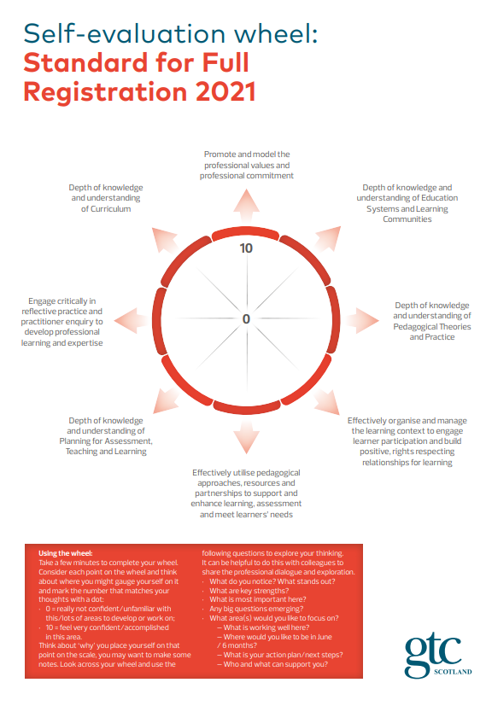
The Standard for Middle Leadership

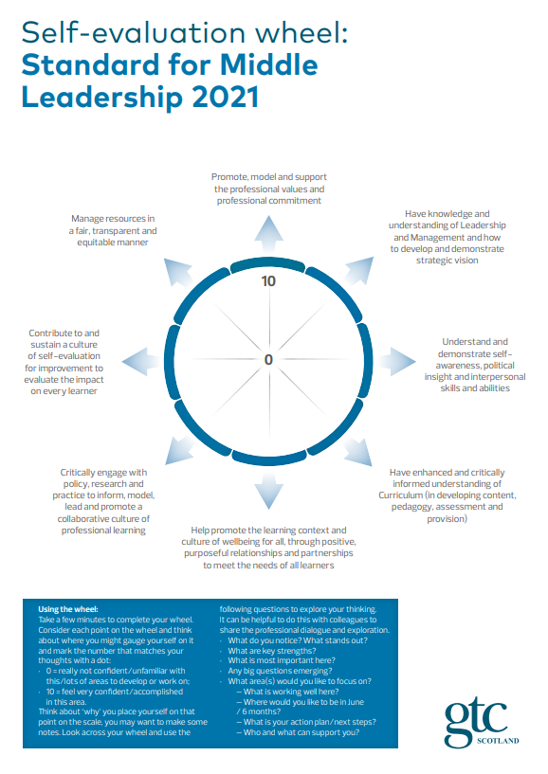

The Standard for Headship
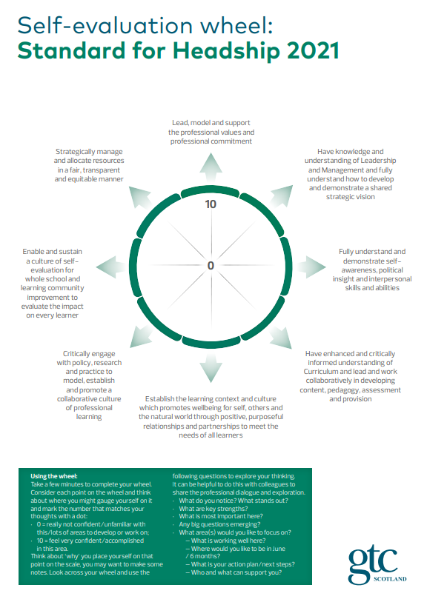

The Standard for Career Long Professional Learning
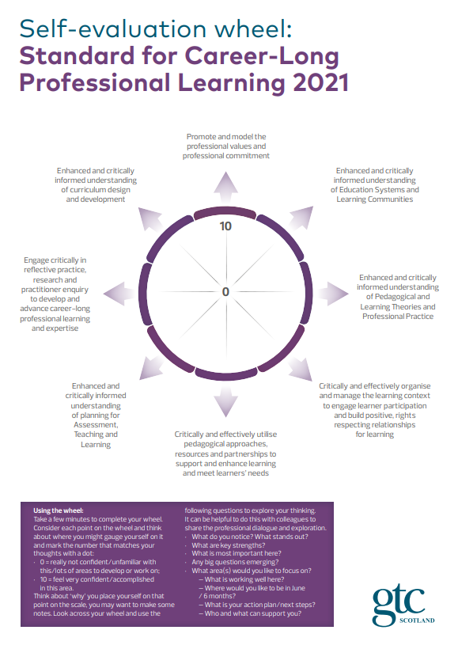

Appendix 4: Ten key features of PRD (GTCS)

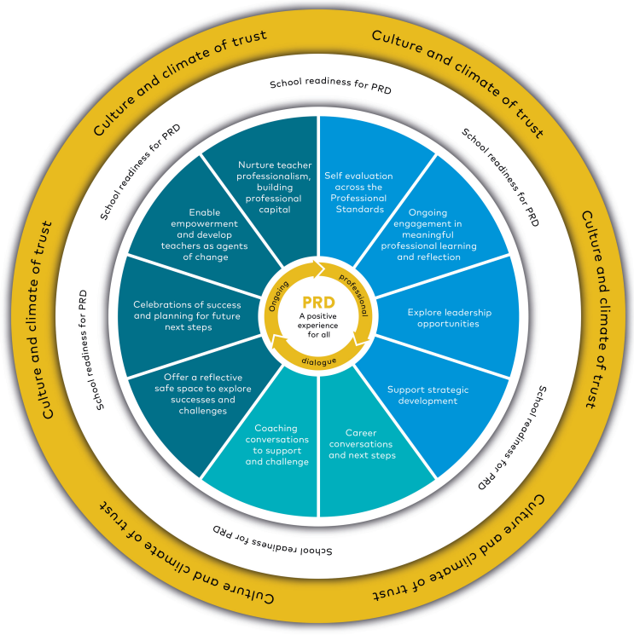
Appendix 5: Professional Learning Planning Cycle (GTCS)

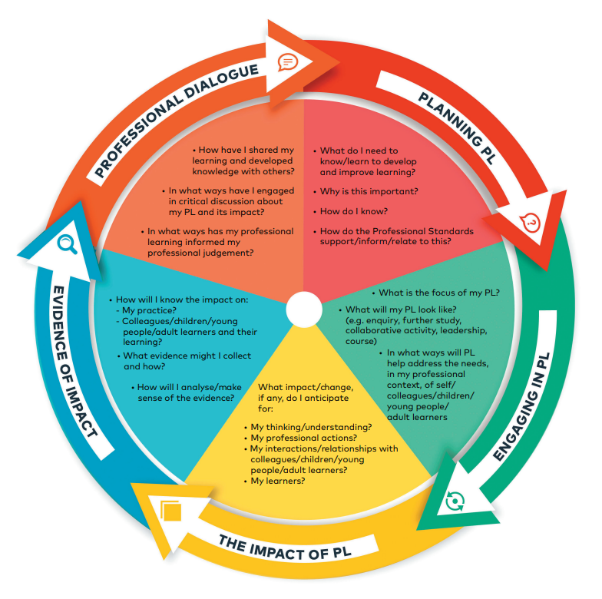

Appendix 6: National Model of Professional Learning

